CONNECTION CODE:
package crud_operations;

import com.mongodb.client.MongoClient;
import com.mongodb.client.MongoClients;
import com.mongodb.client.MongoDatabase;

public class MongoDBConnection {
public static void main(String[] args) {
String connectionString = "mongodb://localhost:27017";

try (MongoClient mongoClient = MongoClients.create(connectionString)) {
MongoDatabase database = mongoClient.getDatabase("testdb");
System.out.println("Connected successfully to MongoDB!");
}
}
}
CRUD CODE
package crud_operations;

import com.mongodb.client.*;
import com.mongodb.client.model.Filters;
import com.mongodb.client.model.Updates;
import org.bson.Document;

public class CRUD_Test{

public static void main(String[] args) {

// Connect to MongoDB
MongoClient mongoClient = MongoClients.create("mongodb://localhost:27017");

// Access database
MongoDatabase database = mongoClient.getDatabase("CollegeDB");

// Access collection
MongoCollection<Document> collection =
database.getCollection("Students");

// ==========================
// CREATE (Insert)
// ==========================
Document student = new Document("id", 101)
.append("name", "John")
.append("department", "CSE")
.append("cgpa", 8.7);

collection.insertOne(student);
System.out.println("Document Inserted Successfully");

// ==========================
// READ (Find)
// ==========================
System.out.println("\nStudent Records:");

FindIterable<Document> students = collection.find();

for (Document doc : students) {
System.out.println(doc.toJson());
}

// ==========================
// UPDATE
// ==========================
collection.updateOne(
Filters.eq("id", 101),
Updates.set("cgpa", 9.2)
);

System.out.println("\nDocument Updated Successfully");

// ==========================
// READ Updated Record
// ==========================
Document updatedStudent =
collection.find(Filters.eq("id", 101)).first();

System.out.println("\nUpdated Record:");
System.out.println(updatedStudent.toJson());

// ==========================
// DELETE
// ==========================
collection.deleteOne(Filters.eq("id", 101));

System.out.println("\nDocument Deleted Successfully");

// Close connection
mongoClient.close();
}
}
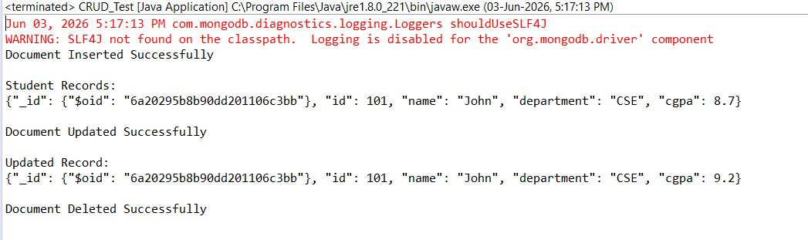

ADDING MULTIPLE
package crud_operations;

import com.mongodb.client.*;
import com.mongodb.client.model.Filters;
import com.mongodb.client.model.Updates;
import org.bson.Document;
import java.util.Arrays;

public class CRUD_Test{

public static void main(String[] args) {

// Connect to MongoDB
MongoClient mongoClient = MongoClients.create("mongodb://localhost:27017");

// Access database
MongoDatabase database = mongoClient.getDatabase("VishaalDB");

// Access collection
MongoCollection<Document> collection =
database.getCollection("Books");

// ==========================
// CREATE (Insert)
// ==========================
Document B1 = new Document("id", 101)
.append("name", "The Great Gatsby")
.append("genre", "Satire")
.append("author", "F scott Fitzgerald");

Document B2 = new Document("id", 102)
.append("name", "No Country For Old Men")
.append("genre", "Drama")
.append("author", "Cormac Mcarthy");

Document B3 = new Document("id", 103)
.append("name", "The Preacher")
.append("genre", "Graphic Novel")
.append("author", "Garth Ennis");

Document B4 = new Document("id", 104)
.append("name", "The Witch")
.append("genre", "Comedy")
.append("author", "Roald Dahl");

collection.insertMany(Arrays.asList(B1, B2, B3, B4));

System.out.println("Document Inserted Successfully");

// ==========================
// READ (Find)
// ==========================
System.out.println("\nBook Records:");

FindIterable<Document> Books = collection.find();

for (Document doc : Books) {
System.out.println(doc.toJson());
}

// ==========================
// UPDATE
// ==========================
collection.updateOne(
Filters.eq("id", 101),
Updates.set("cgpa", 9.2)
);

System.out.println("\nDocument Updated Successfully");

// ==========================
// READ Updated Record
// ==========================
Document updatedBook =
collection.find(Filters.eq("id", 101)).first();

System.out.println("\nUpdated Record:");
System.out.println(updatedBook.toJson());

}
}
